Session 3
Q1.

Create a functional component named ProductCard that accepts props for productName and price, and displays them in a styled div.
Ans.
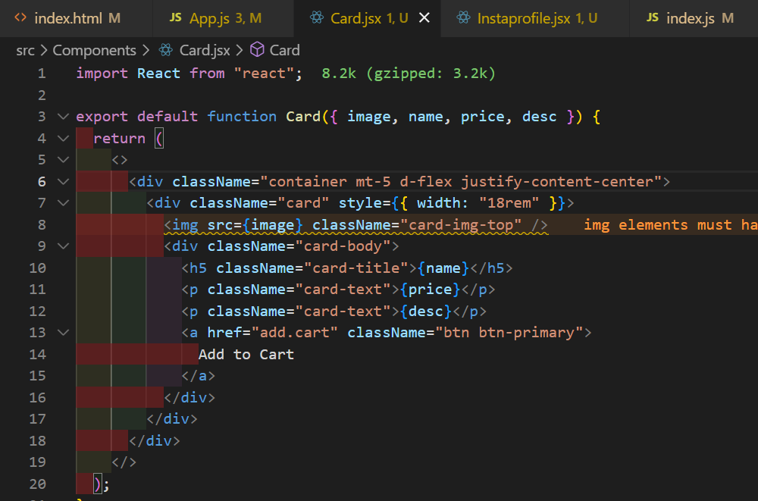
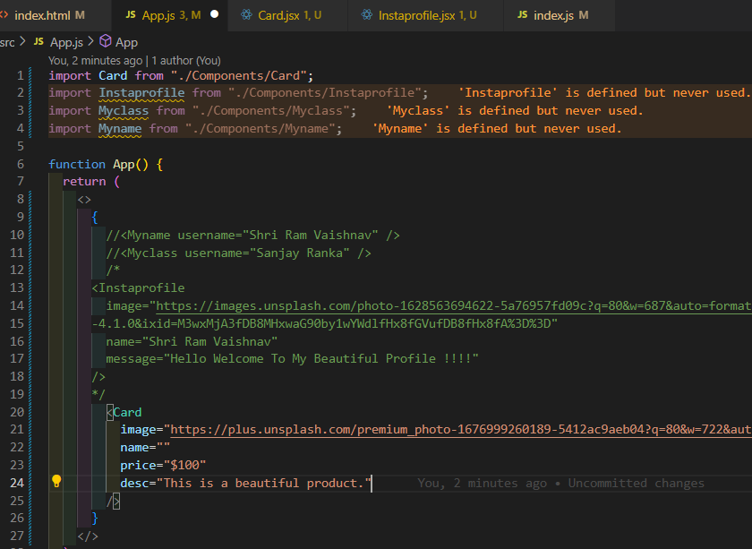
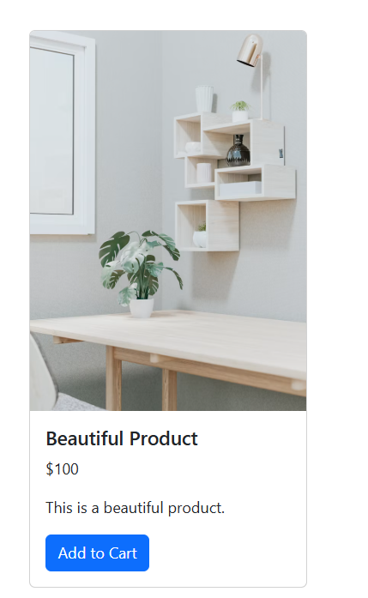

2.
Build a UserProfile component that takes username, followers, and profilePic as props and renders a mini Instagram-style profile card.
Ans.

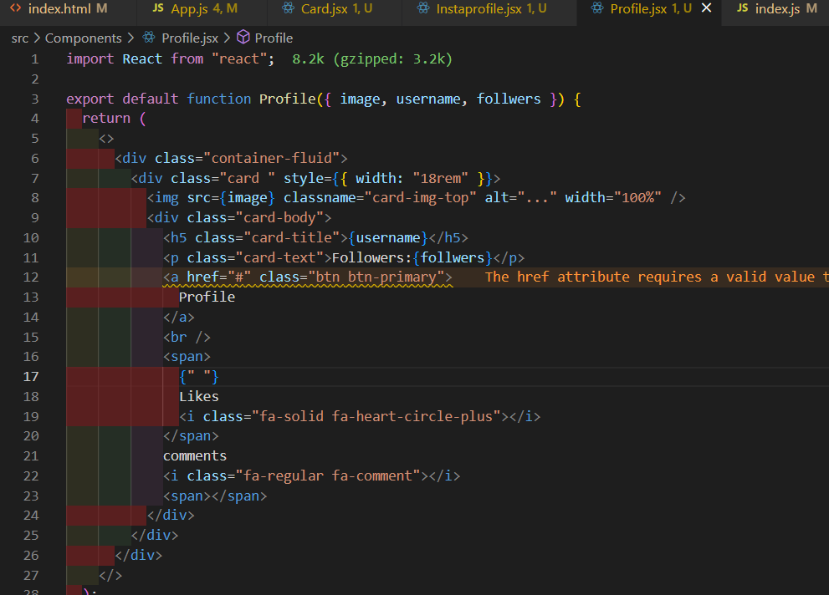

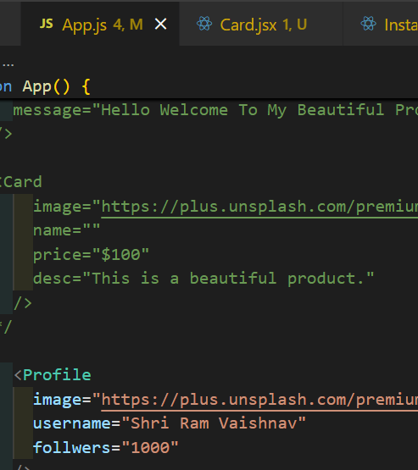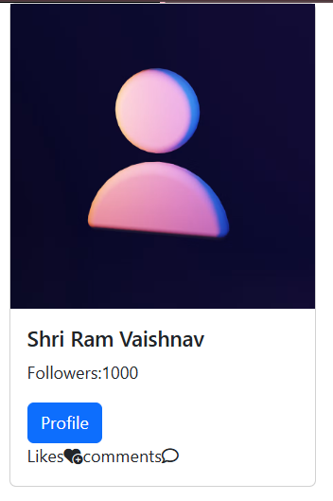

3.
Set up default props for your UserProfile component so that if followers or profilePic is not provided, it shows 0 followers and a default image URL.<br><br><em><strong>Hint:</strong> Use the defaultProps property to set fallback values.</em>

Ans.
